# Medicaid - Compass Enhancements Job Aid

**Description:** Screenshots and guidance of the sections to be filled out in Compass when initiating a new Grievance.

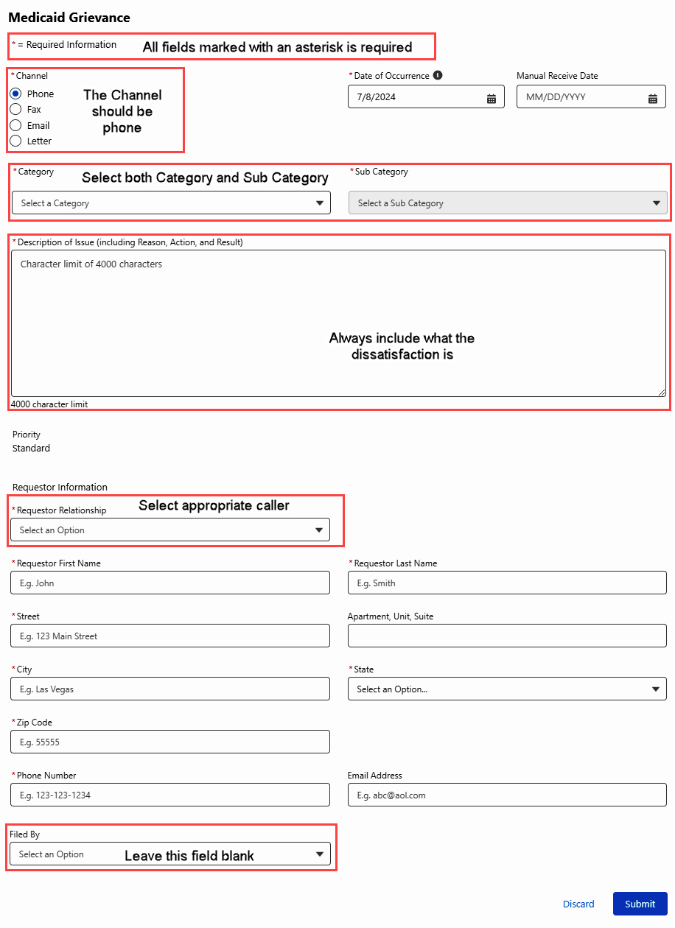

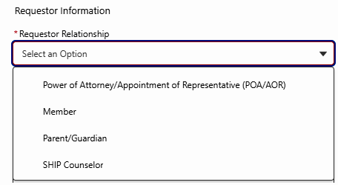

If Requestor Relationship is **Member**.

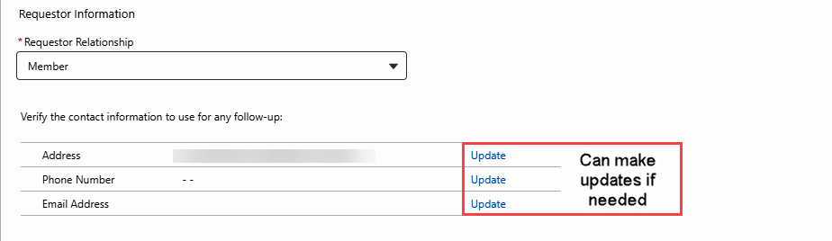

If Requestor Relationship is **SHIP Counselor**.

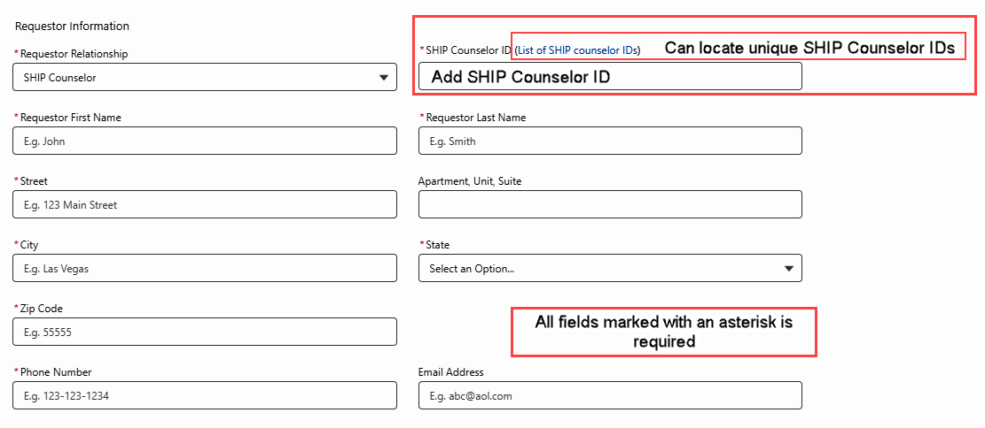

Top of the Document

Not to Be Reproduced or Disclosed to Others without Prior Written Approval

**ELECTRONIC DATA = OFFICIAL VERSION – PAPER COPY – INFORMATIONAL ONLY**